** Selected2 cover sheet **

**Faculty of computer and artificial intelligence.**

**CS396_Selected CS2 (2021-2022).**

**Team: #30**

|  |  |
| --- | --- |
| **Name** | **ID** |
| **Ali Ehab Ali Yousef** | **201900483** |
| **Nehad Ahmed Ali NourEldein** | **201900902** |
| **Nehal Ashraf Elsayed Elsayed** | **201900903** |
| **Mohamed Ashraf Abdelaziz Ibrahim** | **201900635** |
| **Mohamed Hassan Ali Amen Hendy** | **201900654** |
| **Omar Abdel Nasser Tawfik Adam** | **201900517** |
| **Hesham Mahmoud Ibrahim** | **201900942** |
| **Nourhan Mouhamed Radwan** | **201900916** |

**2-Paper details:**

Received October 26, 2017, accepted December 31, 2017, date of publication January 25, 2018, date of current version March 19, 2018.

*Digital Object Identifier 10.1109/ACCESS.2018.2796722*

Image Classification Based on the Boost

Convolutional Neural Network

SHIN-JYE LEE (1), TONGLIN CHEN (2), LUN YU (2), AND CHIN-HUI LAI (3)

1. Institute of Technology Management, National Chiao Tung University, Hsinchu 30010, Taiwan
2. National Pilot School of Software, Yunnan University, Kunming 650091, China
3. Department of Information Management, Chung Yuan Christian University, Chungli 302023, Taiwan

Corresponding author: Chin-Hui Lai (chlai@cycu.edu.tw)

This work was supported in part by the Key Laboratory of Software Engineering of Yunnan Province under Grant 2017SE202, in part by

the Applied Basic Research Foundation of Yunnan Province under Grant 2016FB104, in part by the Yunnan Provincial Innovation Team

under Grant SJ2016-1, in part by the Natural Science Foundation of China under Grant 61402397, Grant 61663046, Grant 61379032, and

Grant 61662085, and in part by the Ministry of Science and Technology of Taiwan under Grant MOST 106-2410-H-033-013.

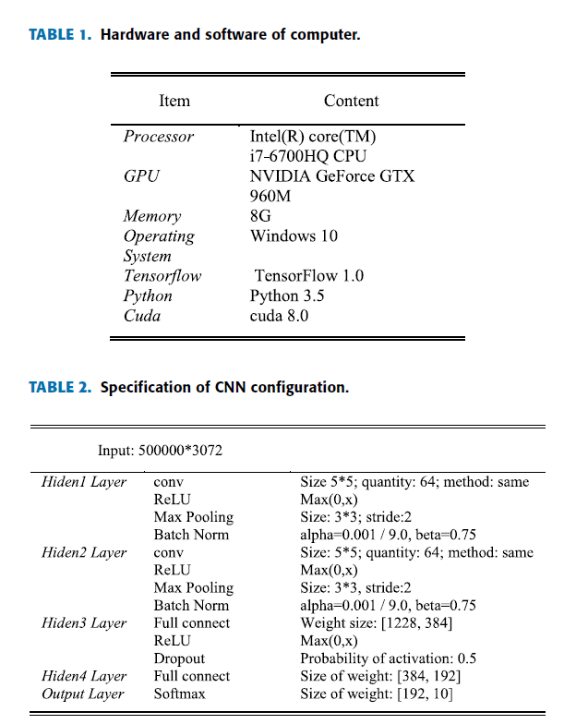

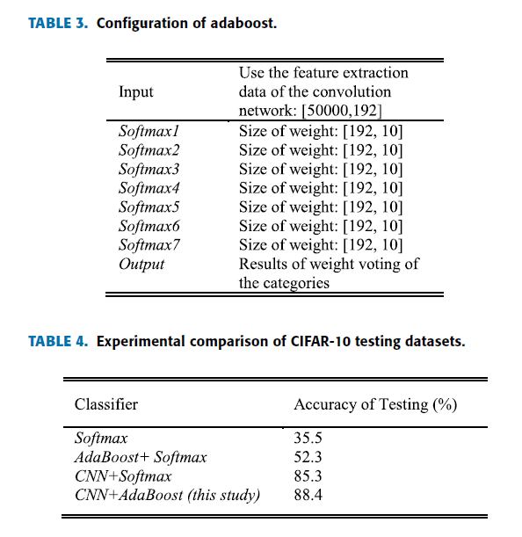

**Project Description Document:**

**General Information on the selected dataset:**

**Rock-Paper-Scissors**

<https://drive.google.com/drive/folders/1ERpc8o3Z1o8srtvMkmrQKGf-5_1ZdiJH?usp=sharing>

Total number of samples: 2892 sample.

the dimension of images: (227, 227, 1).

number of classes: (3).

their labels:

1-paper

2-scissors

3-rock

**CIFAR-10**

<https://www.cs.toronto.edu/~kriz/cifar.html>

Total number of samples: 60000 sample.

the dimension of images: (32, 32, 3).

number of classes: (10).

their labels:

(1-airplane, 2-automobile ,3-bird, 4-cat ,5-deer ,6-dog, 7-frog ,8-horse, 9-ship, 10-truck)

**Implementation details:**

**CIFAR-10**

Training (83.3%=50000 image), validation (16.67%=10000) and testing (16.67%=10000).

**Rock-Paper-Scissors**

Training (87.13%=2520 image), validation (0) and testing (12.86%=372).

CNN on cifar-10

CNN on Rock-Paper-Scissors

**hyperparameters used in your model:**

learning_rate=0.0003

**Rock-Paper-Scissors training model**

**Results details:**

CNN on cifar-10

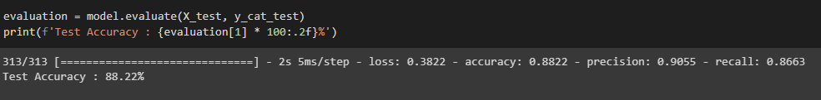

CNN on Rock-Paper-Scissors

